Machine Learning en la Nube (AWS Sagemaker)
Analía Elizabeth Gomory | Salta Capital – Argentina | Año 2025

by Analía Elizabeth Gomory

* ae.gomory@gmail.com

* http://www.linkedin.com/in/elizabeth-gomory-9240b1217

* https://ae-gomory.itch.io

* https://github.com/ElizabethGomory

* https://www.credly.com/users/analia-gomory

* https://orcid.org/0009-0003-0498-7658

1. Uso de un rastreador de AWS con el conjunto de datos GHCN-D

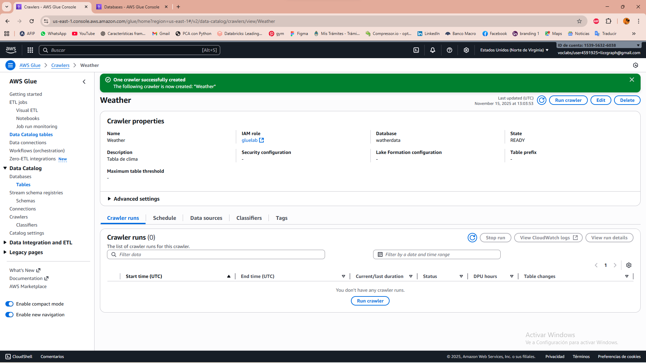
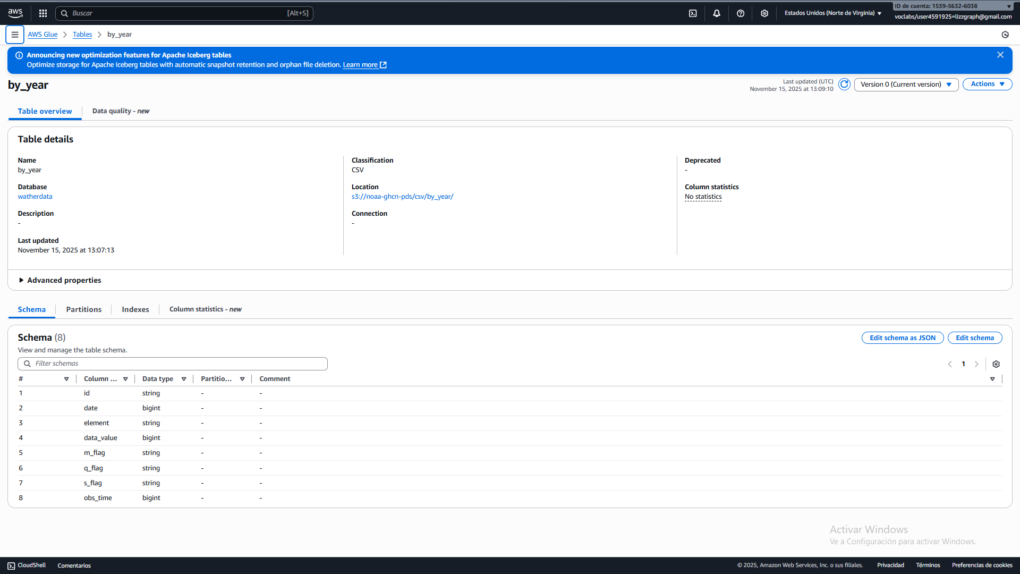

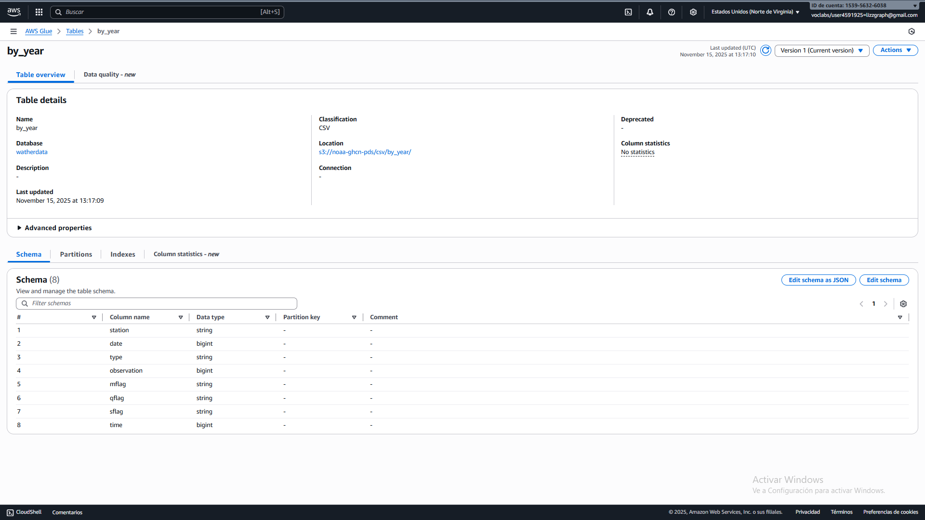
2. Consultar una tabla de Athena

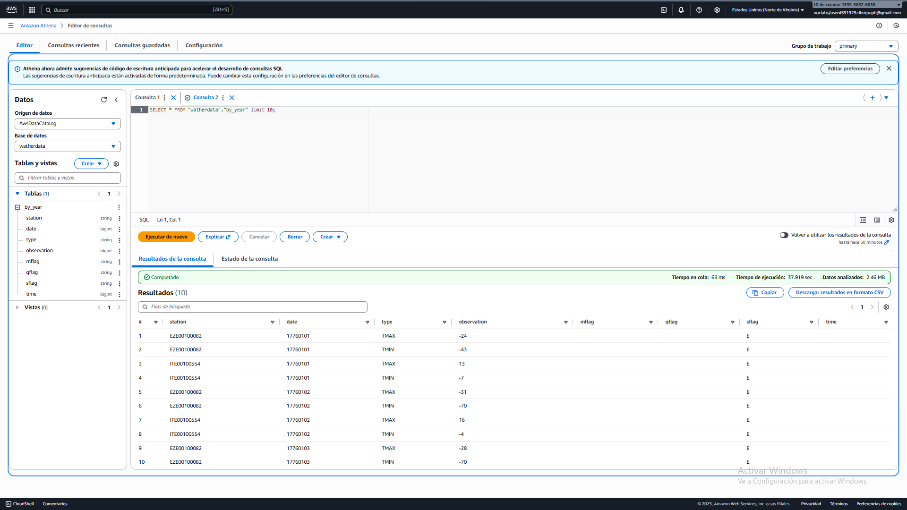
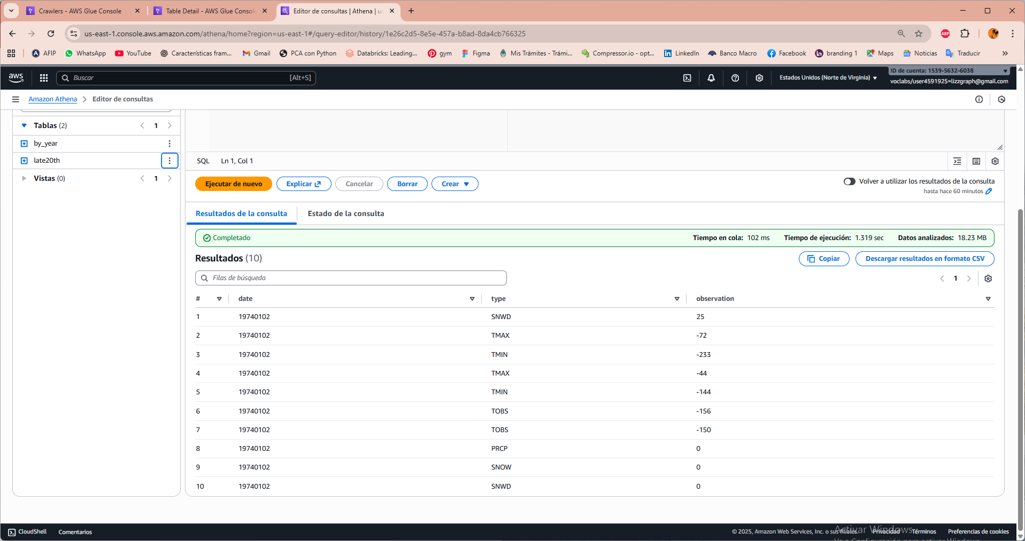

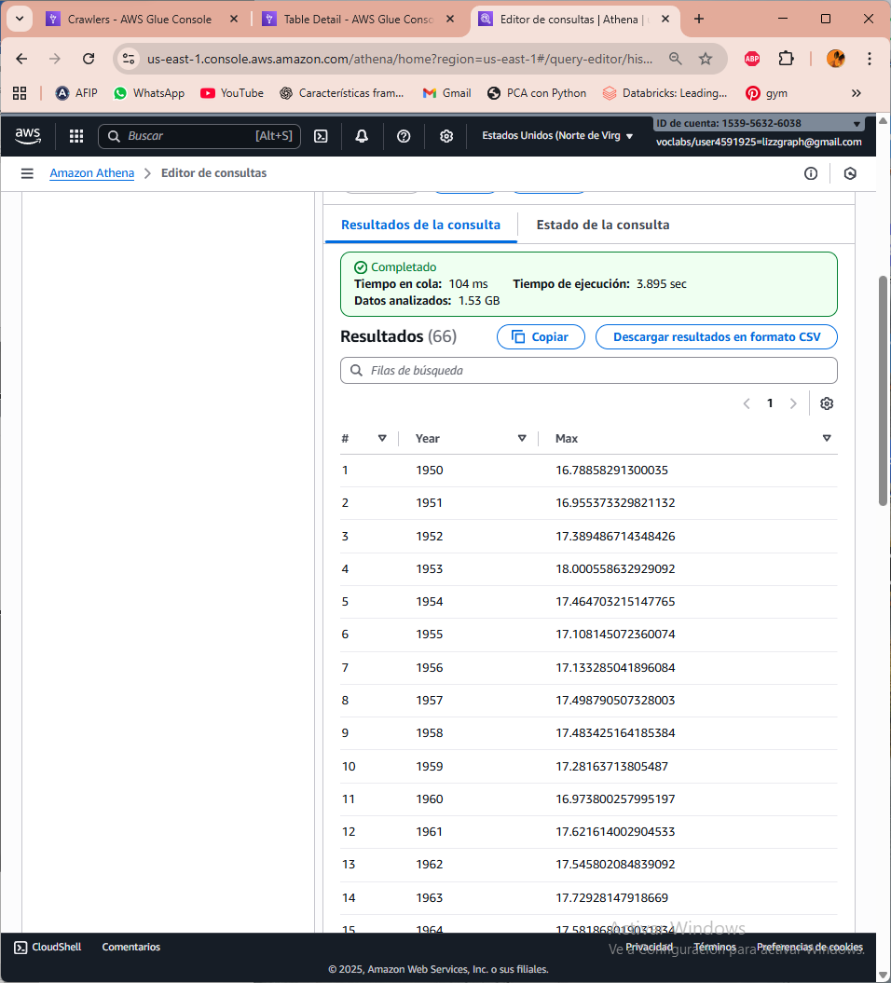
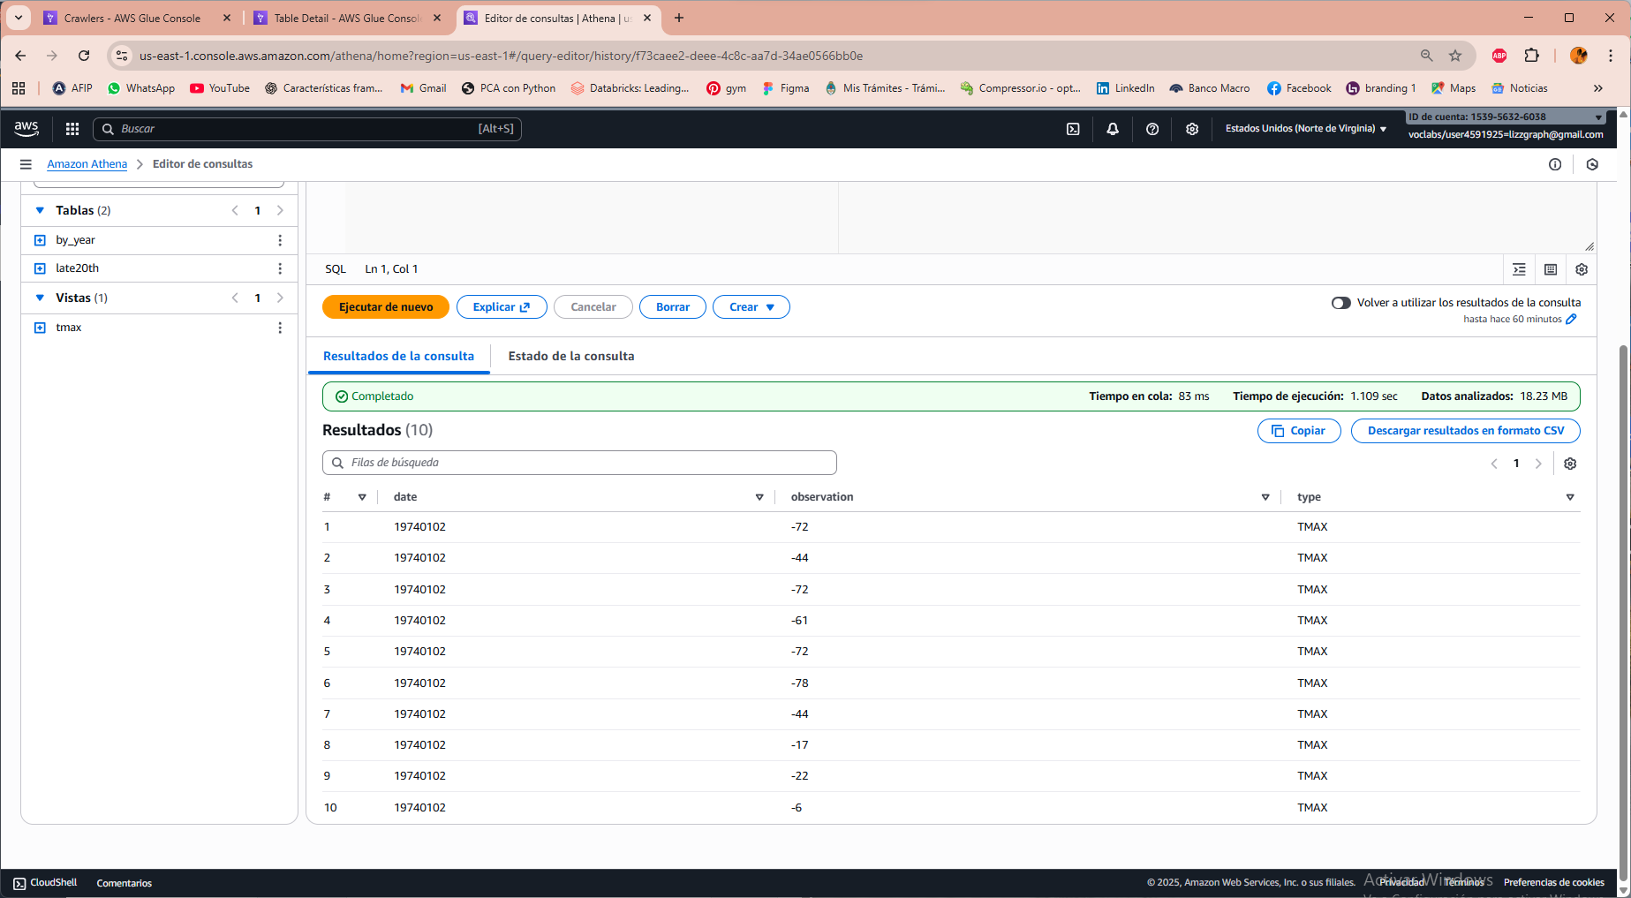

3. Creación de una plantilla de CloudFormation para un Crawler AWS Glue
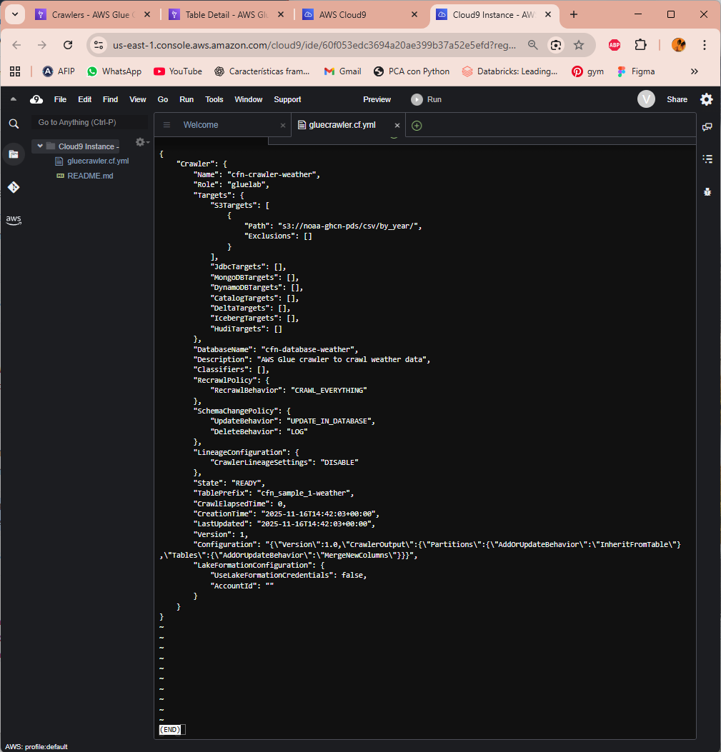
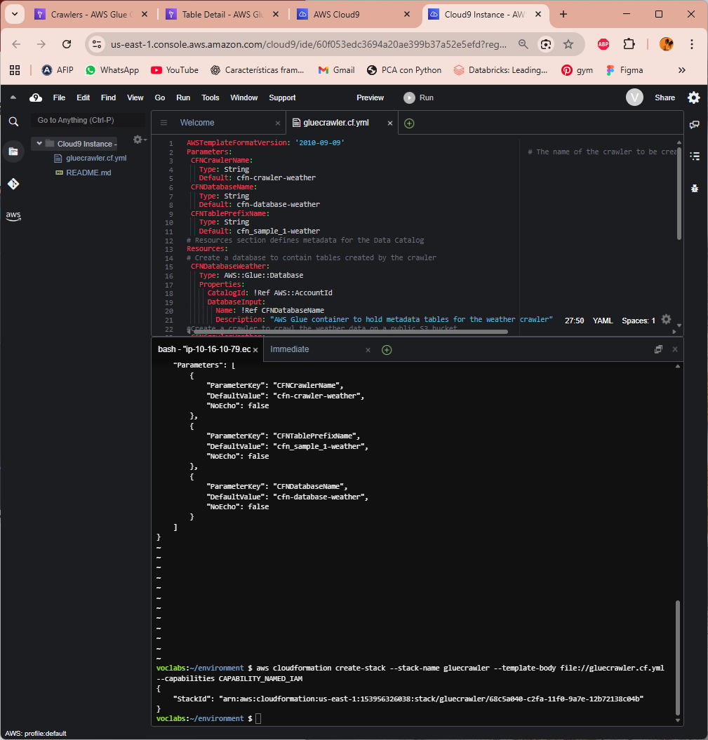
4. Revisión de la política de IAM para el acceso a Athena y AWS Glue

{
"Version": "2012-10-17",
"Statement": [
{
"Action": [
"s3:ListAllMyBuckets"
],
"Resource": "arn:aws:s3:::*",
"Effect": "Allow"
},
{
"Action": [
"s3:*"
],
"Resource": [
"arn:aws:s3:::data-science-bucket--66c9b4c0",
"arn:aws:s3:::data-science-bucket--66c9b4c0/*",
"arn:aws:s3:::glue-1950-bucket--66c9b4c0",
"arn:aws:s3:::glue-1950-bucket--66c9b4c0/*"
],
"Effect": "Allow"
},
{
"Action": [
"s3:Put*",
"s3:Delete*",
"s3:Create*",
"s3:Replicate*",
"s3:Initiate*",
"s3:Restore*",
"s3:Abort*",
"s3:Update*",
"s3:Bypass*",
"s3:ObjectOwner*",
"s3:RestoreObject"
],
"Resource": [
"arn:aws:s3:::glue-1950-bucket--66c9b4c0",
"arn:aws:s3:::glue-1950-bucket--66c9b4c0/*",
"arn:aws:s3:::data-science-bucket--66c9b4c0",
"arn:aws:s3:::data-science-bucket--66c9b4c0/*"
],
"Effect": "Deny"
},
{
"Action": [
"glue:*"
],
"Resource": "*",
"Effect": "Allow"
},
{
"Action": [
"glue:Batch*",
"glue:Cancel*",
"glue:Create*",
"glue:Delete*",
"glue:Import*",
"glue:NotifyEvent*",
"glue:Put*",
"glue:Register*",
"glue:Remove*",
"glue:Reset*",
"glue:Resume*",
"glue:Run*",
"glue:Update*",
"glue:Use*"
],
"Resource": "*",
"Effect": "Deny"
},
{
"Action": [
"Athena:*"
],
"Resource": [
"arn:aws:athena:*:*:datacatalog/*",
"arn:aws:athena:*:*:workgroup/*"
],
"Effect": "Allow"
},
{
"Action": [
"athena:CreateDataCatalog",
"athena:UpdateDataCatalog",
"athena:CreatePreparedStatement",
"athena:CreateNamedQuery",
"athena:UpdatePreparedStatement",
"athena:DeleteWorkGroup",
"athena:DeleteDataCatalog",
"athena:DeleteNamedQuery",
"athena:DeletePreparedStatement",
"athena:UpdateWorkGroup",
"athena:CreateWorkGroup"
],
"Resource": [
"arn:aws:athena:*:*:datacatalog/*",
"arn:aws:athena:*:*:workgroup/*"
],
"Effect": "Deny"
}
]
}

5. Confirmar que Mary puede acceder y usar el rastreador web AWS Glue
